1. Display the system's date.



2. Display the whole calendar for the year 2003

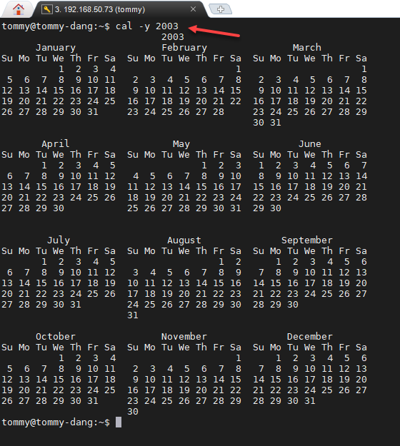

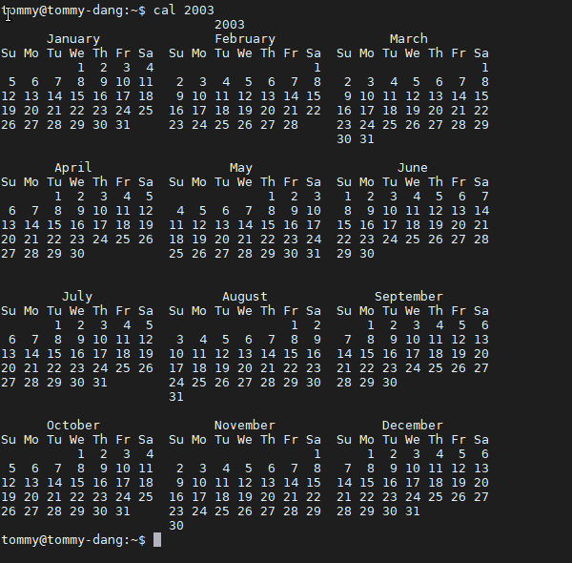

3. Display the month of January for the years 1999 and 99. Are 1999 and 99 the

same?

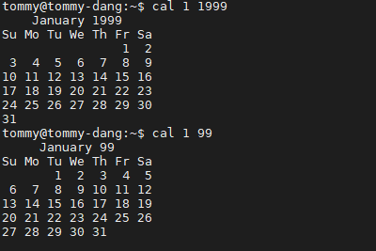

They are not the same

4. There are two commands that will display information about all users currently

on the local system. Display who is currently logged in on your system. Check to

see when they logged in.

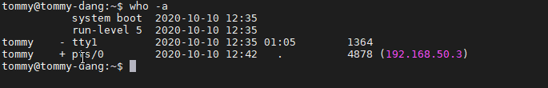

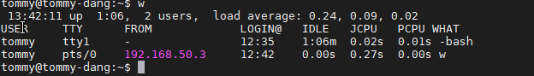

5. Display just your login name.

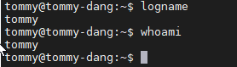

6. Use the **echo** command to write the character string ***Out to Lunch*** to your

display.



7. Use the **clear** command to clear your screen.

8. Login to the system.

9. Using the **pwd** command, verify that you are in your home directory,

/home/student, the directory where you are placed when you first login.



10. Change your current directory to the root directory (/).

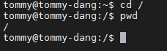

11. Verify that you are in the root directory and then execute both a simple and a

long listing of the files in that directory

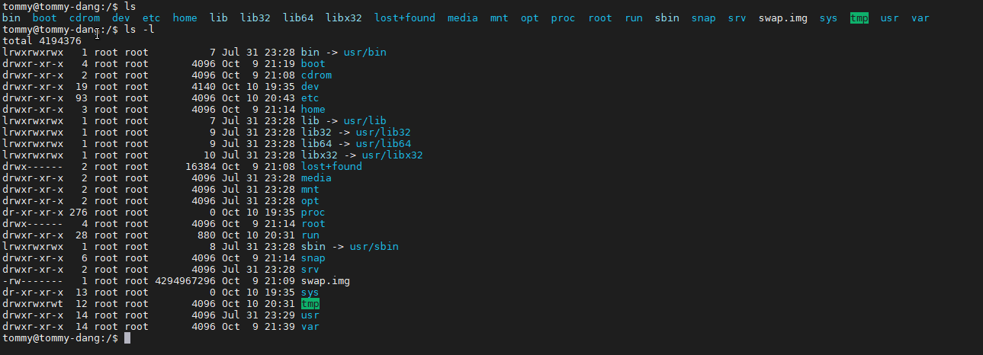

12. Issue the **ls** command with the **-a** and the **-R** options. What is the effect of each

option?_______________ (Note: The ls -R will provide extensive output. Once

you have seen enough, do the key sequence <Ctrl-c> to end the command.)

-a :



-R:



13. Return to your home directory (/home/student) and list its contents including

hidden files.



14. Bring up the **man** pages for the **man** command. Read the text that follows to

obtain a better understanding of the functionality of the **man** command

15. Using the **man** command, search on the keyword **calendar**. From the list

produced, find the command that displays a calendar

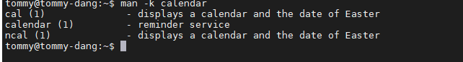

17. List the previous command you’ve already run – history

18. Re-run the 20th command - !20

19. Delete the 20th command from your history – history -d 20

20. Clear all history – history -c